# Introduction

Most commuters rely on public transports, by Transport for Ireland (TFI), to maneuver throughout the city. With the rapid growth of technology, many applications were developed by the TFI in order to ease the process of transactions to lower the costs of kiosks. Specifically, the Leap Card Top-up app that has the main purpose of balance tracking and management of a TFI card (Leap Card). A conducted user research has helped outline the design problems of the application. And based on the conducted research, a redesign can be made for the next potentially iteration of the application.

# Problem Identification

The Leap Card Top-up application did not meet certain standards expected from its own users. This was outlined by the research conducted using social media, surveys, and application’s review on both Android and iOS platform. It had helped highlight the common issue of the application which is that the users lack patience and time for the current top-up process.

The problem identification process is consisted of the creation of personas, empathy map, and story boards. These methodologies have helped gaining a deeper understanding of the users and their needs. The empathy map has helped sympathizing with the personas. In which a story board can be created to help visualize the users and their struggles when using the application.

Many of the users’ frustrations comes from the underlying issue of the application’s interface. The interface can be rendered as inefficient as certain elements of the application is not self-explanatory. An example of this is the scanning process, it must be done multiple times in order to achieve a simple topping-up task. The total time it takes to top up a leap card has been extended as a result of the manual entering of a credit/debit card. There is no clear indication whether the current leap-card is tapped on or off. One of the most vital issues of the application is that it does provide enough accessibility such as language preferences and application feedback for those with disability.

The application is relied on by those who are a frequent commuter and with the current version of the application – it does not meet the user’s needs, especially those in urgency. Users value their time and simplicity of a task in which the application does not provide at all. These factors rendered the application as inefficient. And as a result, changes are required to be made to achieve the expected standard. Otherwise, it would affect the overall reputation of the TFI, their products, and the recurring customers.

# Design Research

Looking at other countries that provoke citizens to use public transport such as the Netherlands. They have developed an application called NS Travel Planner, it is a real-time transport planner used in the Netherlands, specifically for trains. It is rated a five stars application on the iOS app store. Its features include a Real-time travel information, Crowd forecast and seat finder, Purchase tickets on the application, Monitor route and delay notifications, Authentication and linked travel card, and international language support

Comparison of application can be made between the Leap Card Top-up application and the NS Travel Planner application has outline a drastic difference in the product standard. The Leap Card Top-up application lacks many useful features that the NS Travel Planner has. Additionally, the user’s reviews and ratings on the various platforms has highlighted that the NS Travel Planner application is meeting the users’ needs. Therefore, the redesign iteration can be inspired by the NS Travel Planner application.

# Updated Design

The updated design process includes developing a paper prototype of the application to rapidly obtain feedback without wasting many resources. However, the proposed updated design of this report is created using high fidelity design as it further defines the look and feel of the prototype. The goal of this updated design is to reduce the issues of the current Leap Card Top Up application while enhancing the overall user’s experience.

The colour pallet chosen for this updated design consists of pastel colours. Pastel colours are colours that are diluted from a primary colour. It appears soothing and calming to the users while enhancing the cleanliness of the application’s looks and feels (Fussell, 2019).

The use of icons is visible throughout the application, icons are important as it portrays the intended action when done correctly (Babich, 2016).

This is the home page of the application; in this updated design it consists of a linkable account. The purpose of this is to enable the users to have their TFI leap card information saved without having to scan their card multiple times. As a result, it would hasten the process of topping up their leap card, in which many users of the current application have issues with. The card that has been scanned will also be saved within the application whether the user is logged in or not. This increases the flexibility of the application (NDA, n.d.). Additionally, the home page will show the current card’s information such as the balance and the card active indicator (tapped on).

Another page of the updated design include a Luas stop searcher. The page inherits information from the Google Map API and display closest stops to the user by default. Upon clicking on a stop from the map, it will show the relevant Luas line, destination, and wait time. Additionally, the user can also add a certain stop to their favourite stop.

This updated design of the topping up page completely removes the inefficient circular slider from the original application. Instead, it implements a direct button with values that the user can instantly click. This page also provides a warning when the balance is running low, this improves the tolerance for error (NDA, n.d.). Additionally, the user can also enter a custom amount that they’d like to top up indicated by the edit icon.

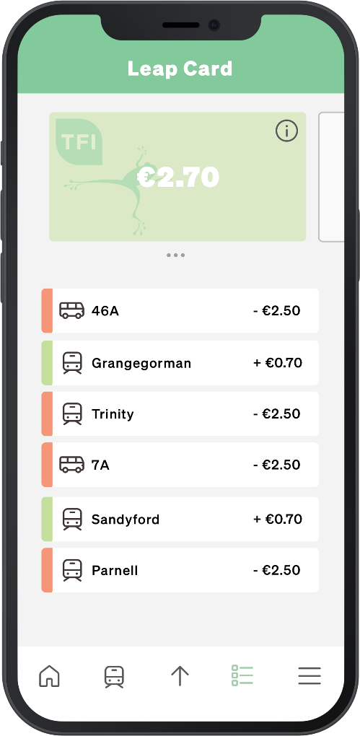

This page relays information of the leap card’s travel history. It shows the different type of transport for each transaction. The information of the transaction is also portrayed by the red and green which indicates the expenses and refunds. However, for user’s privacy the bus number or Luas stop should not be recorded by default.

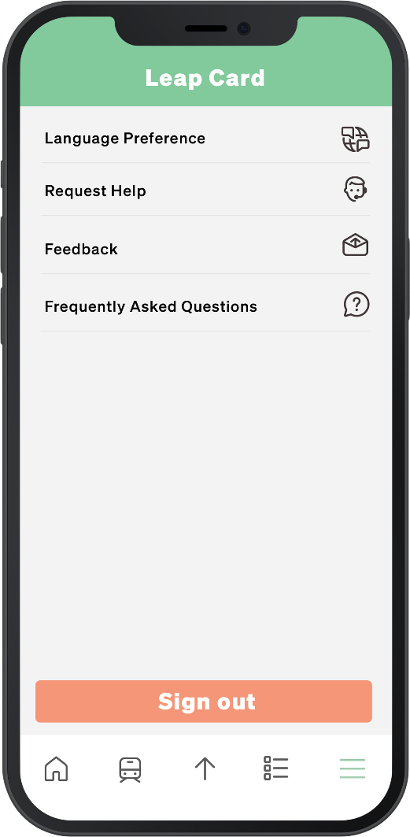

This is the last page of the application, here the users are given accessibilities option such as language preferences, help desk, and a frequently asked questions section.

# Evaluation of Prototype

The evaluation protocol used for the updated design is the Nielsen’s heuristics for usability. This protocol is used to inspect the usability of the proposed design. Testers were actual users who used the current version of leap card application.

|  |  |  |  |
| --- | --- | --- | --- |
| # | The Problem | Heuristic(s) that the design violates | Severity 1 – lowest  5 - disastrous |
| 1 | Contrast of pastel colours and white | Visibility | 1 |
| 2 | Lack of labels in navigation bar | Visibility | 1 |
| 3 | Font weight | Visibility | 1 |

# Conclusion

A possible next iteration of the leap card application has been made catered to the user’s needs. The user research has helped outline the problem statement of the application. In which enable the process of redesigning the application. The proposed design has followed heuristic approach to design a functional and usable application. Though, a high-fidelity prototype were preferred in this report rather than the paper prototype as it completely visualizes the design. The design has taken inspiration from the NS Travel Planner app that has been widely used within the Netherlands. The new design minimizes issues from the current version of the application based off the heuristic evaluation completed.

# References

1. National Disability Authority (NDA). (n.d.). The 7 Principles. The 7 Principles | Centre for Excellence in Universal Design. Retrieved from <https://universaldesign.ie/what-is-universal-design/the-7-principles/>
2. Fussell, G. (2019, October 23). Subtle but Powerful: Using Pastel Colors in Your Designs. The Shutterstock Blog. Retrieved from <https://www.shutterstock.com/blog/use-pastel-colors-designs>
3. Babich, N. (2016). Icons As Part of a Great User Experience — Smashing Magazine. Smashing Magazine. Retrieved from <https://www.smashingmagazine.com/2016/10/icons-as-part-of-a-great-user-experience/>